Working with monitor

Aghasalim Agharahimov  
Rahim Rustamov

Table of Contents

Introduction 2

Overview of the code 2

Detailed analysis of key components 3

Functionality Overview 3

Potential Areas for Enhancement 3

Conclusion 4

**1. Introduction**

The purpose of this project is to develop a pattern generation program using the Hack assembly language for the Hack computer architecture. The primary goal is to create an aesthetically pleasing pattern on a display screen, showcasing the capabilities of the assembly language and the underlying hardware architecture.

**2. Overview of the Code**

The provided assembly code consists of several integral components essential for pattern generation. These components include initialization of memory locations, implementation of looping structures, execution of arithmetic operations, manipulation of memory, and control of screen output. 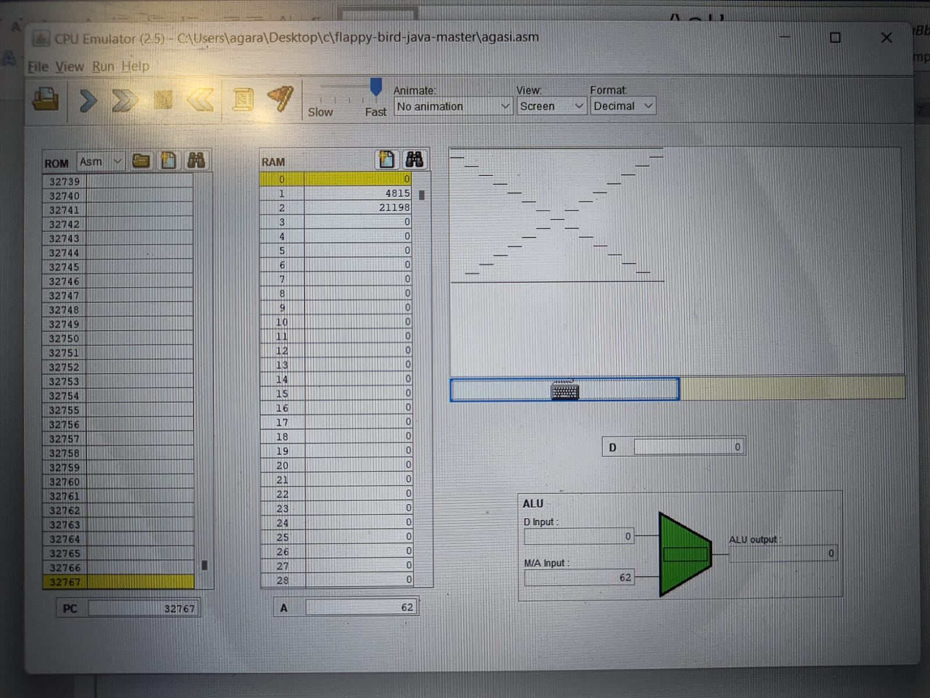

**3. Detailed Analysis of Key Components**

Initialization Phase: The program initiates memory locations 0, 1, and 2 with predefined values to establish initial conditions necessary for subsequent operations.

Looping Structures: Labeled loops with conditional jumps are utilized to iteratively execute specific instructions, effectively controlling the flow of the program.

Memory Manipulation: Extensive use of memory operations enables the storage of intermediate results and facilitates the updating of values during computational tasks.

Arithmetic Operations: Addition and subtraction operations play a pivotal role in computing screen coordinates and determining the activation of pixels within the pattern.

Screen Output Control: The program utilizes memory writes to the SCREEN memory location to indicate pixel activation, thereby generating the desired pattern on the display.

**4. Functionality Overview**

Through meticulous orchestration of memory operations, arithmetic calculations, and screen updates within structured loops, the assembly code achieves the intended outcome of displaying a coherent pattern on the screen. The program effectively translates abstract instructions into tangible visual output, showcasing the power and versatility of the Hack assembly language.

**5. Potential Areas for Enhancement**

To further refine the project, several enhancements can be considered:

Comprehensive Code Documentation: Adding detailed comments and documentation within the code would enhance readability and comprehension, facilitating easier understanding and future modifications.

Modularization and Code Refactoring: Breaking down complex operations into modular components with well-defined functions would improve code organization, reusability, and maintainability.

Error Handling Mechanisms: Incorporating error-checking mechanisms and exception handling routines would enhance the program's robustness and reliability, ensuring smooth execution under various scenarios.

**6. Conclusion**

In conclusion, the assembly code successfully demonstrates the generation of an intricate pattern on the display screen using the Hack architecture. By leveraging the inherent capabilities of the assembly language and carefully orchestrating memory operations and arithmetic calculations, the project achieves its objectives effectively. With further enhancements in documentation, modularization, and error handling, the project can be refined to optimize code quality and facilitate future development efforts.